Nutrient Levels in Streams near New Zealand’s Lake Rotoiti

Katherine McFarlane, Madison Lambert, Micael Lonergan

March 17, 2018

**Abstract**

New Zealand’s water quality is in question despite recent articles suggesting the country’s waterways are still clean and green. In this study, we tested water in surrounding streams near Lake Rotoiti for nitrate levels and algae health. We hypothesized that in areas such as farmland and landfills that nitrate levels would be higher and algae would respond positively to this. Areas upstream and downstream from farmland and landfills were examined. Traces of nitrate were found in Black Valley Streams downstream from a farm, and algae health was lower in this area. Although findings are not conclusive, it is suggested that further testing be done in this area.

**Introduction**

Lake Rotoiti, a small waterway in the Nelson Lakes National Park of New Zealand, is known for its clean water quality (Smith 1999). Government testing on the lake, which was last done in 1999, insists that the lake was then “virtually unaffected by human activities” and that “the quality of the lake environment ha[d] not changed significantly in the past 25 years,” implying that the lake would continue to boast clean waters in the foreseeable future (Smith 1999). Swimming is also allowed in Lake Rotoiti, which is indicative of the water quality (“Nelson Lakes…” 2014). These quality levels, which draw in tourists, are in keeping with that which New Zealand is famous for. The clean and green status New Zealand prides itself on, however, may be a myth. According to freshwater scientists, “freshwater ecosystems are degrading, more so than marine and terrestrial ecosystems, contributing to the biodiversity crisis” (Elston, et al. 2014: 5). Another resident scientist states that, “In the figurative sense of environmental integrity, our land is much less green than we choose to pretend” (Wallace 1999: 22). Specifically in the Lake Rotoiti area, many algal blooms are present during summer times, and a study of algal growth tells that algae is most likely to grow when there are high levels of nitrate and phosphorus, both of which can be caused by farming (“What causes…”). Similarly, Black Valley Streams that lead into the lake indicate some cause for concern, for the streams are in contact with nearby farming and recreation areas that may contribute to contamination (“Water Quality Results…,” 1999; Wallace 1999: 28). As such, this experiment investigated water quality on the Black Valley Streams. It was believed that nitrate levels would be higher in areas downstream from land that humans had intervened on, such as farmland and landfill areas, and that algae would be healthier, so areas upstream and downstream of these sites were tested.

**Methods**

*Site Selection*

Upon arriving in the Nelson Lakes National Park, five sites were selected from nearby farmland. Site one was upstream from the farm; site two was located on the farm outside of the fencing surrounding a pasture; site three at a landfill; site four at the bottom of the neighborhood downstream from the farm; and site five inside a pasture area on the farmland. All sites were selected with the assistance and permission of the Borlases, who own the Borlase farm, at which the study took place.

*Water Collection*

Over the course of three days, three 1.5 mL bottles full of water were collected from each of the five sites that had been chosen. The three collection spots at each site were close together (within three feet apart). The bottles were then brought back to sit in coolers for one to two hours before testing began.

*Water Testing*

After the sediment and nutrients were allowed to settle within the bottles, they were brought out for testing. API Freshwater Master Test Kits were used to test for levels of pH, high range pH, ammonia, nitrite, and nitrate. All testing was done per the manufacturer’s instructions.

After this, still using the sunlight deprived water, the bottles were taken out and the majority of the water was drained off so the water left at the bottom that held much of the settled life could be accessed. 3 mL was then extracted and put into another test tube and placed inside the Pulse Amplitude Modulated (PAM) Fluorometer. The PAM was then used to test this water by exposing the test tube to differing amounts of light. A relative light curve (RLC) was then output by the software.

Then, outlier data points were taken out to ensure accuracy of the data, and through ANOVA tests alpha, Pmax, and R2 values were determined for each of the three samples taken from the five sites. For each site, the data from the three samples was averaged so that sites had a single alpha, Pmax, and R2 value. Standard deviation was also generated for alpha and Pmax values.

**Results**

Of the five sites sampled, two (sites four and five) had trace amounts of nitrate (five parts per million) found within the water of each of the three samples (see Table 1). Site four was located downstream from the neighborhood that housed the farmland, and site five was found within the fences surrounding a pasture on the Borlase farm. pH, ammonia, and nitrite were within expected levels. pH ranged from 6.4 to 7.2, and trace amounts of ammonia were found in one sample. Otherwise, no ammonia or nitrite were found.

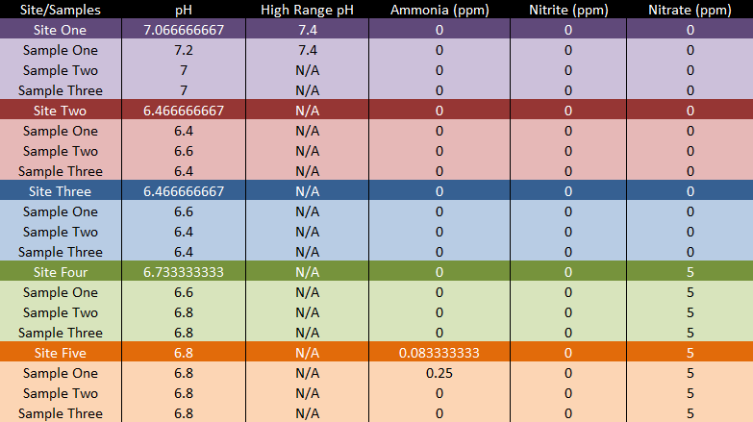

Table 1. pH and nutrient testing done at each of the five sites. Findings are averaged for each of the tests and displayed on the top, darkest colored bar for each section.

The RLCs show that sites four and five both have low-valued light curves, while in contrast, sites one, two, and three all have relatively high-valued light curves (see Figure 1). Although some graphs do not represent consistent curves, the three samples taken from each site are spaced fairly close together for each of the sites (excepting one sample from site two). R2 values, which can be determined from this figure, are indicative of health, with healthiest samples resulting in values closest to 1. Site one had a value of 0.9713 and site three had a value of 0.817, which were the highest values. Site four had the lowest value of 0.1666.

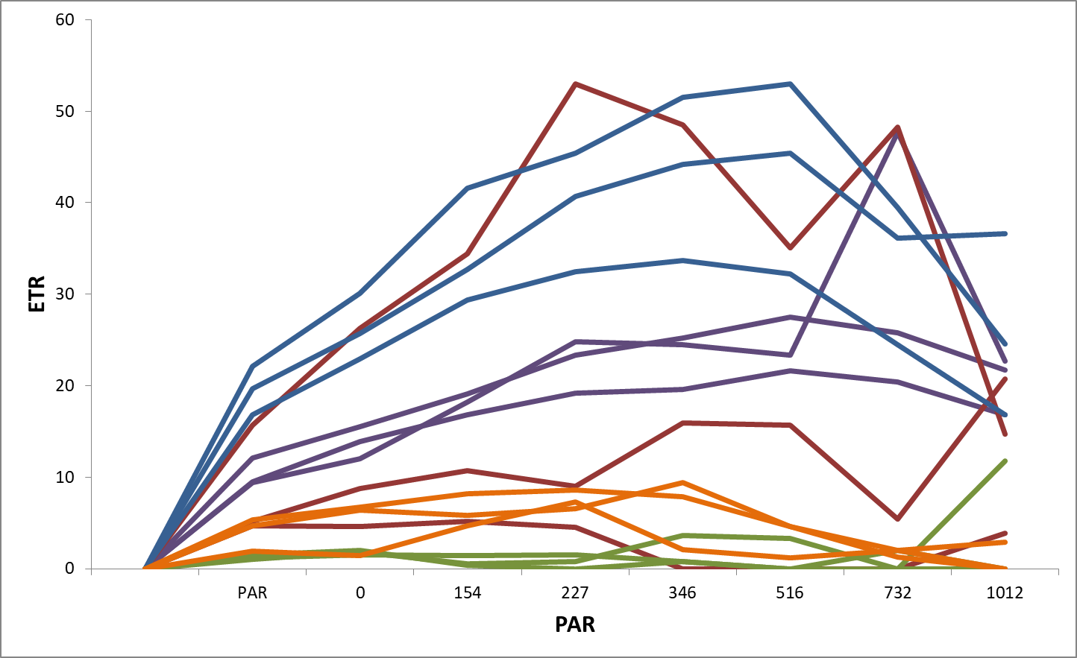

Figure 1. Relative light curves for each site, with the independent variable representing photosynthetic active radiation (PAR) and the dependent variable representing electron transport rate (ETR) to show the overall health and photosynthesis levels of the algae and the peak point at which the organisms are given too much sunlight. Colors for each site match Table 1.

Alpha and Pmax values, which respectively represent the photosynthetic efficiency of the organisms and the capacity for photosynthesis within the biota, were also measured (see Figure 2 and Figure 3). Alpha values were high in site five and relatively low elsewhere. Pmax values were highest in sites one and three and very low in sites four and five.

Figure 2. Average alpha levels per site, indicating photosynthetic efficiency. Standard deviation is also pictured.

Figure 3. Average Pmax value per site, indicating overall capacity for photosynthesis. Standard deviation is also pictured.

**Discussion**

The purpose of this experiment was to analyze the effects of farming and other human interventions on Lake Rotoiti’s surrounding streams. Our findings suggest that the streams may not be as clean as possible and that more testing must be done to determine where the problem lies. Because sites four and five contained traces of nitrate, it is possible that they have been contaminated by the work of humans. When comparing the RLCs, one can see that sites four and five are shown to contain less healthy algae – although they still produce consistent curves. Only site one has a very healthy R2 value that the rest of the sites lack, with site three being the second healthiest. From the testing, it can be said that sites one and three are healthier and get more sunlight based on R2 levels and Pmax values for these sites, which somewhat aligns itself with the experimental hypothesis: site one was upstream from the farm, and site three was near a landfill that had been covered and has not been interacted with by humans recently. Site four, despite containing nitrate that may lead to flourishing algae, appears unhealthy based on site four’s RLC and the low efficiency of photosynthesis, seen from the alpha values. Pmax values tell readers the level of light the algae is accustomed to, and therefore matches our expectations when comparing to Figure 2 except in the case of site four, which is neither efficient nor receives much sunlight. Site five seems to be healthier in this regard: the organisms are thriving well on the sunlight that is received, as told through the alpha value, although the site is getting less sunlight (seen from pmax values, despite a large standard deviation for this result). Still, some questions are left. The alpha values show that only site five is undergoing photosynthesis efficiently, while sites one and three are very inefficient. In comparison to the RLCs for site one and three, this is unexpected. Finally, site two had high standard deviations and less consistent graphs and therefore gives little relevant information.

This study is not conclusive, however. Results from the API Freshwater Master Kit did not show that all the water near farmland and the landfill were impacted by nitrates and other nutrients, and furthermore the graphs gave no fully conclusive data. Some had large standard deviations while others seemed to contradict other findings of this project. There were also problems with the methods: not all of the water was collected on the same day, and it had recently rained in the area, which may have affected some of the water quality.

However, many factors play into these tests, and although it would be jumping to conclusions to say that humans are having extensive ill-effects on the water and algae health in Lake Rotoiti and surrounding areas, it is also unlikely that the area is entirely unaffected by the work of humans (Smith 1999). Nitrate is not necessarily an unwelcome nutrient, and the addition of nitrate in water can often lead to healthy algae (“What causes…”). However, it is the fact that the rapid light curves yielded from the areas with more nitrate come back looking unhealthy that should pique the interest of readers. This may happen for many reasons: there could be a lack of algae in the water to begin with, or the algae may have been unhealthy because of other nutrients that were not tested for in the study. No matter the reason, though, these results call for the need for more testing.

In conclusion, it is necessary to begin consistent testing to ensure the accuracy of the water quality in this region and elsewhere in this country. For farmers, water quality laws are often detrimental to their way of life. Such laws often cost money and force farmers and workers to work alongside the government, which, as seen from the Borlases, many farmers are unwilling to do because of past experiences with lawmakers (Lambert et al. 2018). This is understandable, as for them, this means more regulations and less economic growth as money must be spent on water quality testing and prevention of adverse nutrient flow. Because of this, some farmers stay just beneath the legal limits so that they can pass these tests while saving money (Duncan 2014). However, we need to ensure the health of the public and preserve New Zealand’s nature. This is not just a water issue, either, for “unsustainable land use practices, familiar and routine, are a deep seated problem that New Zealand must address urgently … many of the farming techniques we learnt and which are still being practised, must change if we are to address the degradation of water quality, the poisoning of aquifers, the loss of soil quality and fabric, and the disappearance of native species” (Wallace 1999: 28). Water gives life to all, and to create and upkeep healthy water laws that all people of New Zealand are willing to work with is to help turn this country into the environmentally friendly and safe place that the people need. It is only through more testing that New Zealanders can regain the clean, green mantra they want to uphold.

References

Apps, Tim. “Testing for Nitrate and Nitrite in Natural Waters.” *Testing Solutions*, Apps

Laboratories.

Duncan, Ronlyn. “Regulating agricultural land use to manage water quality: The challenges for

science and policy in enforcing limits on non-Point source pollution in New Zealand.”

*Land Use Policy*, vol. 41, Nov. 2014, pp. 378–387.

Elston, E., R. Anderson-Lederer, R.G. Death and M.K. Joy. “The Plight of New Zealand’s

Freshwater Biodiversity.” *Society for Conservation Biology*, 2014, pp. 1-14.

Hamilton, David. “Algae in the Rotorua Lakes.” *Lakes Facts*, Environment Bay of Plenty, Jan.

2005.

Hughey, Kenneth F.D., Geoffrey N. Kerr and Ross Cullen. *Public Perceptions of New Zealand’s*

*Environment: 2016*. EOS Ecology, 2016.

Joy, Mike K., and Russell G. Death. “Freshwater Biodiversity.”*Institute of Agriculture and*

*Environment*.

Lambert, Madison, Micael Lonergan and Katherine McFarlane. “General Questions with the

Borlases.” 22 Feb. 2018.

Larned, Scott T., Mike R. Scarsbook, Ton H. Snelder, Ned J. Norton and Barry J.F. Biggs.

“Water Quality in Low‐Elevation Streams and Rivers of New Zealand: Recent State and

Trends in Contrasting Land‐Cover Classes.” *Journal New Zealand Journal of Marine and*

*Freshwater Research*, vol. 38, 30 Mar. 2010, pp. 347–366.

*Nelson Lakes National Park Visitor Information*. Department of Conservation, Rotoiti/Nelson

Lakes Visitor Centre, Mar. 2014.

Parris, Kevin. “Impact of Agriculture on Water Pollution in OECD Countries: Recent Trends and

Future Prospects.” *International Journal of Water Resources Development*, vol. 27, no. 1,

6 Feb. 2011, pp. 33–52.

Smith, R. A. “Water Quality Survey of Lake Rotoiti (South Island).” *National Institute of Water*,

Tasman District Council, 6 July 1999.

Wallace, Cath. “The 'Clean Green' Delusion.” *New Zealand Studies*, Mar. 1999, pp. 22–29.

“Water Quality Results for the Rotoiti Catchment 1999.” *Tasman District Council*, 1999.

“What causes algal blooms?” *Center for Earth and Environmental Science*, Indiana University.